**Mini Project Report on**



**Face Detection**



**Submitted in partial fulfillment of the requirement for the award of the degree of**

**BACHELOR OF TECHNOLOGY**

**IN**

**COMPUTER SCIENCE & ENGINEERING**

**Submitted by:**

**Student Name**  **University Roll No.**

**Gaurav Pundir 20021272**

***Under the Mentorship of***

**Mr. Saurabh Mishra**

**Designation**

**Assistant Professor**



**Department of Computer Science and Engineering**

**Graphic Era (Deemed to be University)**

**Dehradun, Uttarakhand**

**January 2023**



**CANDIDATE’S DECLARATION**

I hereby certify that the work which is being presented in the project report entitled **“Face detection ”** in partial fulfillment of the requirements for the award of the Degree of Bachelor of Technology in Computer Science and Engineeringof the Graphic Era (Deemed to be University), Dehradun shall be carried out by the under the mentorship of **Mr. Saurabh Mishra , Assistant Professor**, Department of Computer Science and Engineering, Graphic Era (Deemed to be University), Dehradun.

Name University Roll no **signature**

Gaurav Pundir 20021272 gaurav

**Table of Contents**

|  |  |  |
| --- | --- | --- |
| **Chapter No.** | **Description** |  |
| Chapter 1 | Introduction |  |
| Chapter 2 | Literature Survey |  |
| Chapter 3 | Methodology |  |
| Chapter 4 | Result and Discussion |  |
| Chapter 5 | Conclusion and Future Work |  |
|  | References |  |

**Chapter 1**

**Introduction**

The goal of this project is to detect and locate human face in image or video using opencv ,cnn and deep learning .

* 1. **Introduction**

Face detection is common practice used world wide with a combination of task as per use . it is made easy with the introduction of AI and Machine learning . In this project we have used a single ‘Triplet ’ training model to train our project in both image and video reorganization.

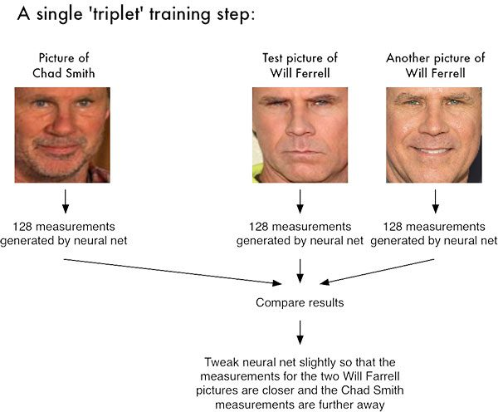

We can easily recognize faces in a video by using 128 -d embeddings on dataset provided . we can train our network from staring and can re -write a pre trained set also . we can also recognize face along with detection .

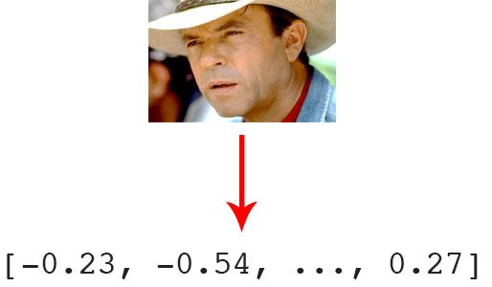

This method uses rejection based classification. The face detector consists of a set of weak classifiers that sequentially reject non-face regions. First, the non-skin color regions are rejected using color segmentation. A set of morphological operations are then applied to filter the clutter resulting from the previous step. The remaining connected regions are then classified based on their geometry and the number of holes. Finally, template matching is used to detect zero or more faces in each connected region

**Chapter 2**

**Literature Survey**

2.1 RELATED WORK

Face detection is defined as the procedure that has many applications like face tracking, pose estimation or compression. Face detection is a two-class problem where we have to decide if there is a face or not in a picture. This approach can be seen as a simplified face recognition problem.

AdaBoost: Adaboost is an algorithm for constructing a strong classifier as a linear combination. Adaboost, short for Adaptive Boosting, is a machine learning algorithm. It is a meta-algorithm and can be used in conjunction with many other learning algorithms to improve their performance. Adaboost is adaptive in the sense that subsequent classifiers built are tweaked in favor of those instances misclassified by previous classifiers. Adaboost generates and calls a new weak classifier in each of a series of rounds. For from a set of training images. This method can be used for both face detection and face locations. In this method, a standard face (such as frontal) can be used. The advantages of this method are that it is very simple to implement the algorithm, and it is easily to determine the face locations such as nose, eyes, mouth, etc. based on the correlation values.

2.2 ALGORITHMS OF FACE DETECTION

Pre-processing and cropping filter: The images of the dataset are already cropped around the face, so there is no need of a face detection stage to localize the face from each image. To do so, we detect 68 facial landmarks using Dlib-ml open- source library. According to the eyes location, we apply a 2D rotation to make them horizontal. The next step is to apply a cropping filter in order to extract only the non- masked region. To do so, we firstly normalize all face images into 240 x 240 pixels. Next, we use the partition into blocks. The principle of this technique is to divide the image into 100 fixed-size square blocks (24 x 24 pixels in our case). Then we extract only the blocks including the non-masked region (blocks from number 1 to 50). Finally, we eliminate the rest of the numbers of the blocks.

Feature extraction layer: They extract deep features using VGG16 face CNN descriptor [20] from the 2D images. It is trained on ImageNet dataset which has over 14 million images and 1000 classes. Its name VGG16 comes from the fact that it has 16 layers. Its layers consist of convolutional layers, Max Pooling layers, Activation layers, Fully connected layers. There are 13 convolutional layers, 5 Max Pooling layers and 3 Dense layers which sums up to 21 layers but only 16 weight layers. In this work, we only consider the feature maps (FMs) at the last convolutional layer, also called channels. These features will be used in the following in the quantization stage.

2.3 PROPOSED SYSTEM

The proposed system focuses on how to identify the person on image/video stream wearing face mask with the help of computer vision and deep learning algorithm by using the OpenCV, Tensor flow, Keras and PyTorch library.

**Chapter 3**

**Methodology**

The face detection work as to detect multiple faces in an image. Here we work on OpenCV for Face Detection, and there are some steps that how face detection operates, which are as follows-

Firstly the image is imported by providing the location of the image. Then the picture is transformed from RGB to Grayscale because it is easy to detect faces in the grayscale.

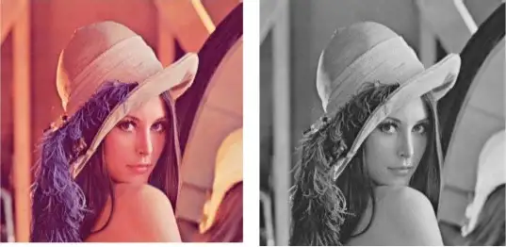

After that, the image manipulation used, in which the resizing, cropping, blurring and sharpening of the images done if needed. The next step is image segmentation, which is used for contour detection or segments the multiple objects in a single image so that the classifier can quickly detect the objects and faces in the picture.

The next step is to use Haar-Like features algorithm, which is proposed by Voila and Jones for face detection. This algorithm used for finding the location of the human faces in a frame or image. All human faces shares some universal properties of the human face like the eyes region is darker than its neighbour pixels and nose region is brighter than eye region

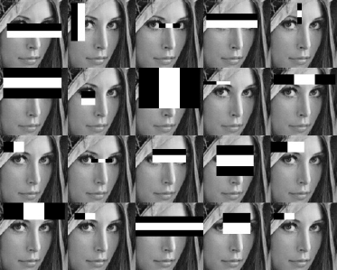

**Chapter 4**

**Result and Discussion**

In the end, integrating such new technology into an application was more difficult than initially considered. Most problems encountered were hard to find solutions to because the computer vision community was lacking experience with the concepts. However, through lots of research, some solutions were found as seen above. Starting with a base foundation of machine learning concepts and mathematical understanding was extremely beneficial in adapting to future concepts and problems. I was successful at implementing and understanding the theory of 2D facial detection and recognition but fell a bit short when processing 3D data. The concepts were well understood, but the coding implementation proved challenging given the circumstances, and a proper database of registered users was not able to be created. However, using the pointcloud method, Brendan was able to have his face recognized first in 2D and verified with 3D data as a registered user inconsistently. We successfully filtered input images and aligned them to a grid, but holes of imperfect image capture are still too frequently present, and the image cropping must be done manually rather than with code. Handling null points seems to be the biggest issue were we to move forward, and more time, testing, and users would be needed in the database to fully finish the system.

**Chapter 5**

**Conclusion and Future Work**

It is my opinion that project in face recognition is an exciting area for many years to come and will keep many scientists and engineers busy. In this paper we have given concepts of face recognition methods & its applications. The present paper can provide the readers a better understanding about face recognition methods & applications. In the future, 2D & 3D Face Recognition and large scale applications such as e-commerce, student ID, digital driver licenses, or even national ID is the challenging task in face recognition & the topic is open to further research.

**References**

[1] C. Garcia and G. Tziritas, "Face detection using quantized skin color region merging and wavelet packet analysis," IEEE Transactions on Multimedia Vol.1, No. 3, pp. 264--277, September 1999.

[2] H. Rowley, S. Baluja, and T. Kanade, “Neural Network-Based Face Detection,” IEEE Transactions on Pattern Analysis and Machine Intelligence, volume 20, number 1, pages 23- 38, January 1998.

[3] M. Elad, Y. Hel-Or, and R. Keshet, “Pattern Detection Using a Maximal Rejection Classifier,” Pattern Recognition Letters, Vol. 23, Issue 12, pp. 1459-1471, October 2002

[4]The Face Detection Homepage,